Obesity Classification Report

In this report we will be attempting to predict and classify a person’s obesity status based on a given dataset. We will also go over a brief exploratory data analysis to get a better understanding of the data we are working with. As well as determining the best model and technique that can predict and classify a person’s obesity status.
Before proceeding with the exploratory data analysis segment a keynote to mention is that the following columns were the most promising based on the multivariate analysis.
- Weight
- family_history_with_overweight
- Age
- daily_water_drinking
- food_between_meals
- Height
- Gender

Exploratory Data Analysis
In this segment we will be analyzing the dataset to get a better understanding of what columns will aid in classifying a person’s obesity. We will also look for any potential anomalies such as missing data or duplicated data that can hinder our progress. Also, we will analyze the data for an y patterns that can help is exploit to prep our data for our models to better learn with.

Initial Data Analysis
This section analyzes the initial values and statistics of our dataset as well as whether our dataset contains empty values and duplicates. Figure 1 shows us what values we are dealing with. We have a mixture of categorical, binary and numerical values. We can also see based on Figure 2 the statistics of the numerical columns.
Figure 1 Dataset initial overview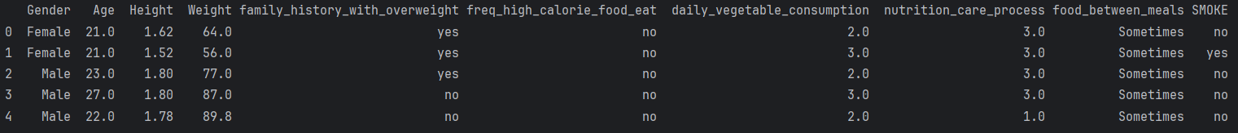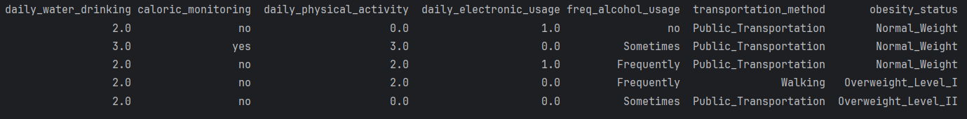
Figure 2 Dataset Statistics
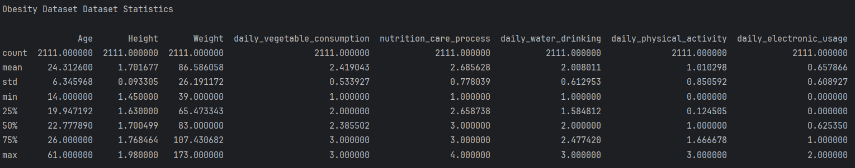
Figure 3 shows us key information about our dataset. We can see whether these columns have missing values or not. Based on the shape of the dataset we can compare the row value of 2111 and the non-null count column. It indicates that each column has 2111 non-null values indicating each column has no missing values.
Figure 3: Checking Dataset for null values
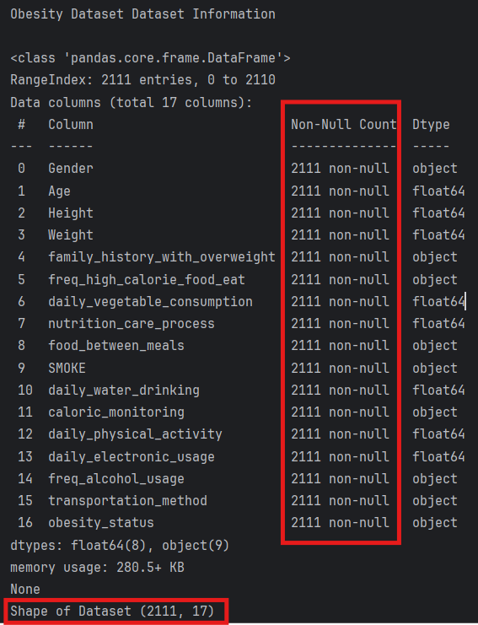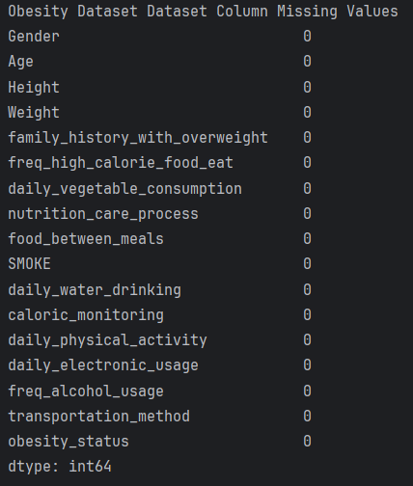

Univariate Column Analysis
This section analyzes each column individually. We will also be viewing the numerical and categorical data columns separately. Starting off with Figure 4 we have histograms of our numerical columns. There is a clear distinction in which numerical columns follow a distribution that include Height, Weight, and Age. The rest are abnormal, indicating the values belong into sections.
Figure 4 Histogram of numerical columns
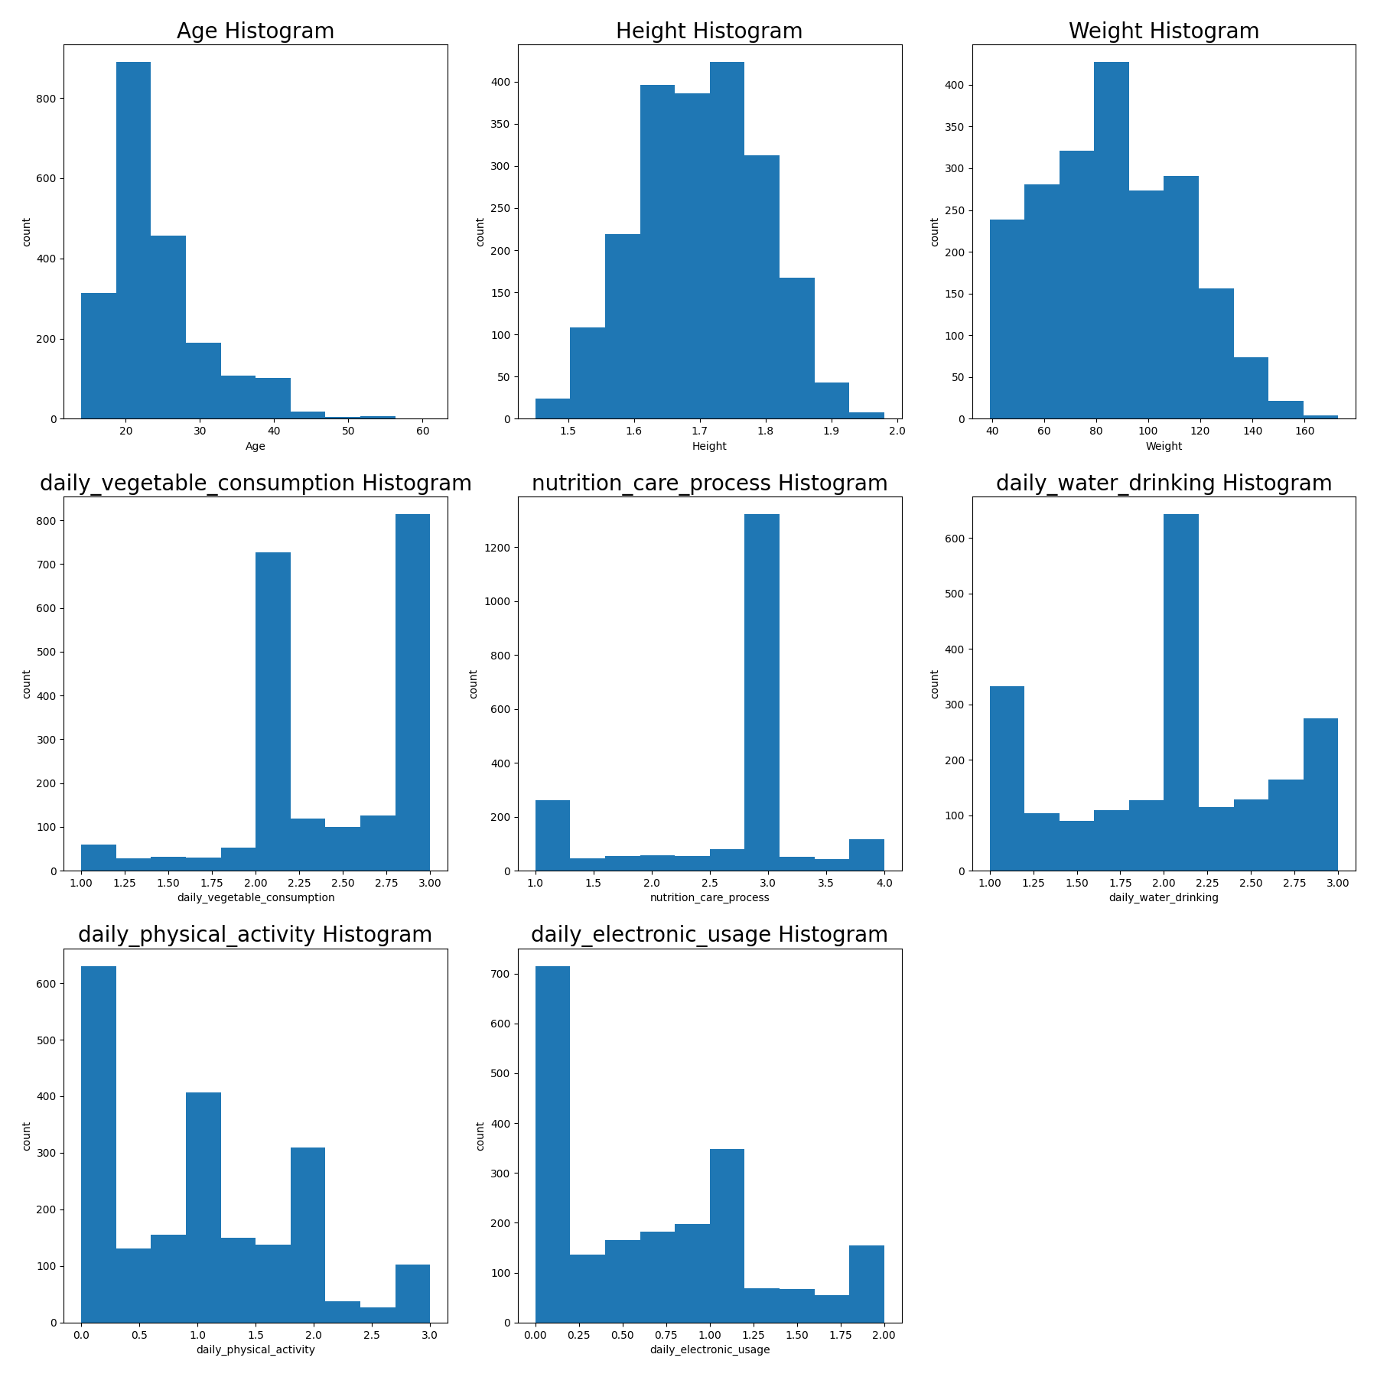

Figure 5 showcases us the categorical columns. Instantly we can see that most of the categories are binary meaning values can be classified in only 2 categories. The following categorical columns food_between_meals, freq_alcohol_usage, transportation_method, and our target variable obesity_status have more than 2 categories we can visit furthermore.
Figure 5 Bar plot of categorical columns
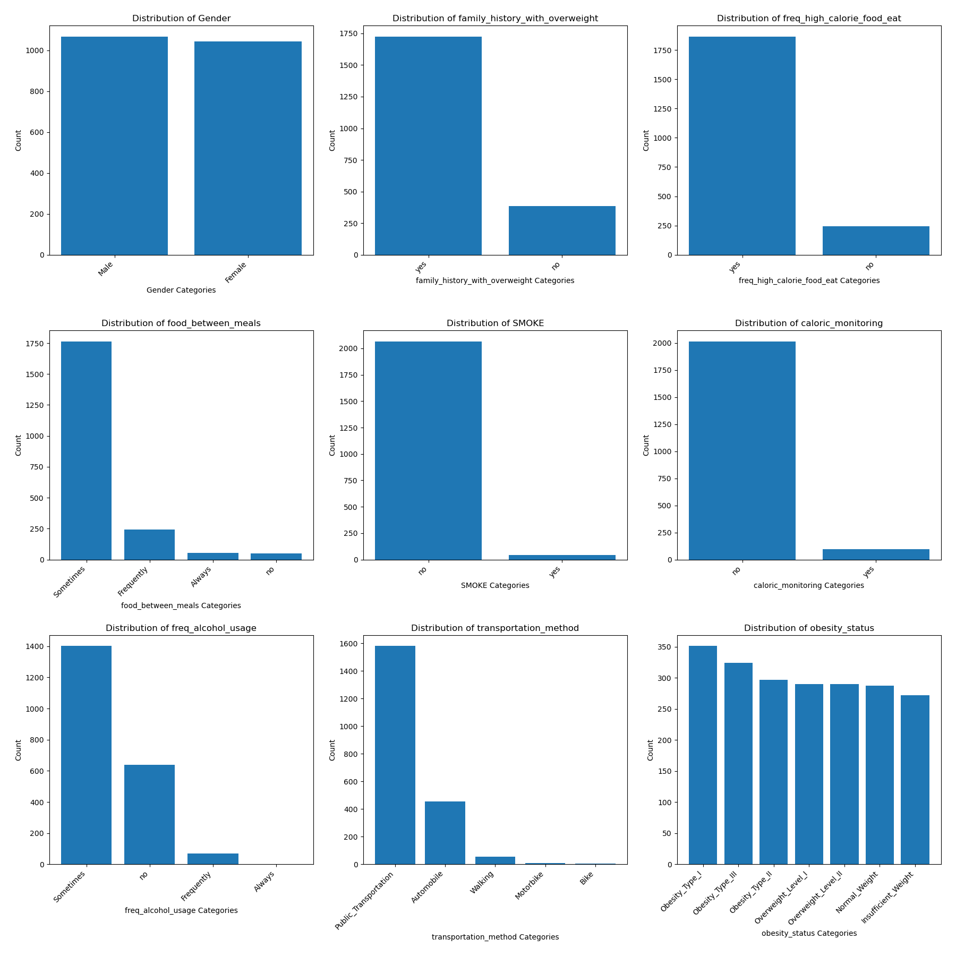

Multivariate Column Analysis
In this segment we will be analyzing the relationships between our target variable and from all of the columns. Before we begin, we will be analyzing Figure 6 heatmap to identify which columns are significant based on the strong colour of the column. From what we can see here there are 4 columns that spark interest. These are Weight, family_history_with_overweight, Age, daily_water_drinking and food_between_meals. These are our most significant variables.
It is also evident that the height column has strong correlations to the gender and weight column. We will further explore the relationship of this data and determine how it can relate to our target variable.
Figure 6 Correlation heatmap
